

***Drive to Succeed*****Application**

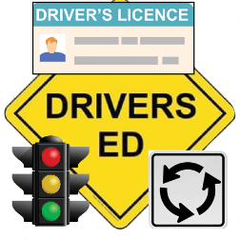

**Please note: Incomplete applications may not be considered for award.   
Typed or legible hand-written applications are accepted. Use current information when filling out the application.**

Student name: ______________________________________________________________________________________

Student address: ____________________________________________________________________________________

City: ___________________________________________ State: _____________ Zip: ________________________

Student Phone number: __________________________________________ Do you text? Yes No

Student E-mail address: ______________________________________________________________________________

Student Birthday (month/day/year format): ______________________________________________________________

Parent/Guardian name: ______________________________________________________________________________

Parent/Guardian Phone number: ___________________________________ Do you text? Yes No

Parent/Guardian E-mail address: _______________________________________________________________________

What high school is your student currently attending? ______________________________________________________

If currently homeschooled or attending a career center, please check: Homeschool Student Career Center Student

Check the program below that you qualify for and attach approved documentation:  
 School reduced/free lunch WIC/SNAP eligibility Medicaid recipient

Briefly explain how this scholarship will help you? _________________________________________________________ ______________________________________________________________________________________________________________________________________________________________________________________________________________________________________________________________________________________________________

I __________________________, have **never** taken a driver’s education class, am **not currently enrolled** in a

Student name

driver education course, **or currently have** a driver’s permit/license.  
I _____________________ agree that the above statement is true. If the **information is found to be untrue** and scholarship is awarded, **student and/or parent/guardian will be charged** for the cost of the driver education class.

Parent/guardian name

Check to confirm that you have attached the following requirements:

Fully completed application Documentation for financial eligibility Letter of recommendation

_____________________________________________ __________________________________________   
**Student Signature Date Parent/Guardian Signature Date**

AB_01/2025

**For office use only:**   
**Date of application received: Date of application reviewed: Was scholarship awarded? Date student notified**